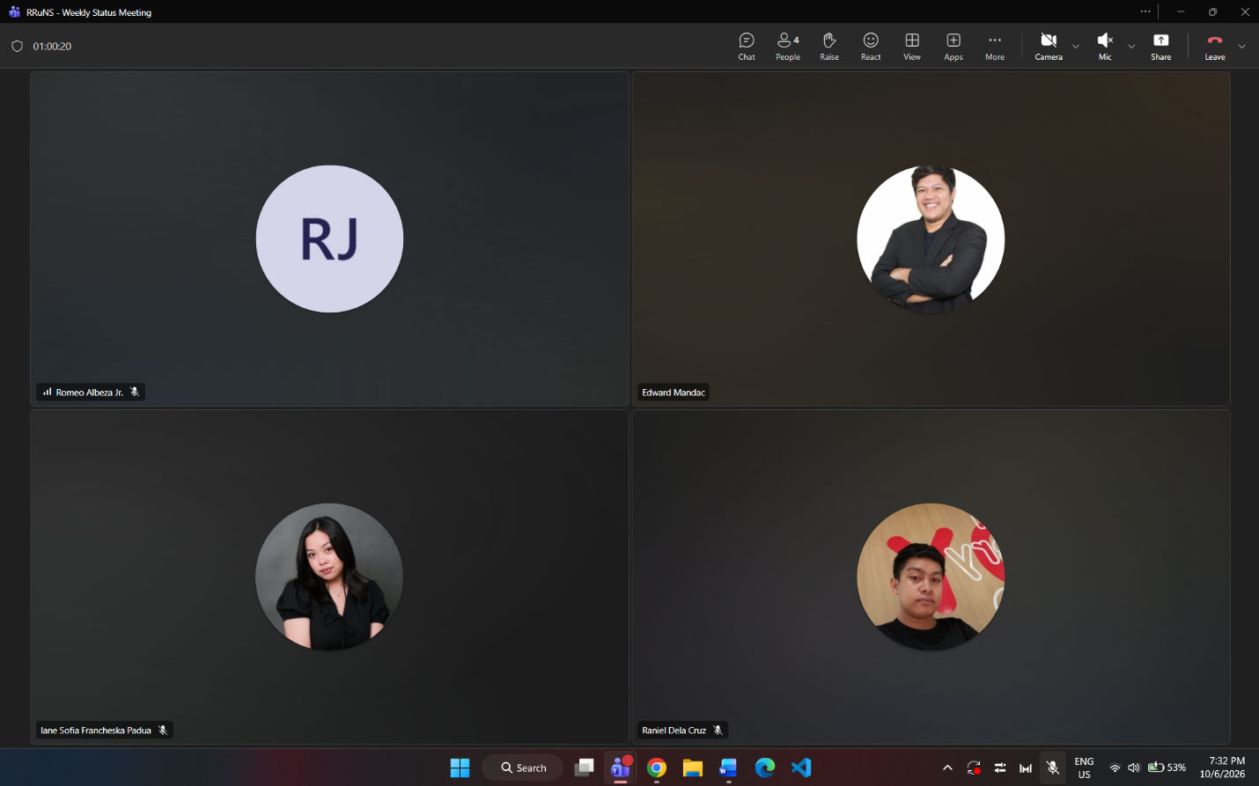
Weekly Status Report: Minutes of Meeting
- Date: Tuesday, October 6, 2026
- Meeting Called By: RRuNS Team
- Facilitator: Edward Mandac
- Link of the Meeting: Weekly Status Meeting Tuesday, 6 October | Meeting | Microsoft Teams
1. Attendees
- Nairb Ackillis Varona
- Romeo Jr. Albeza
- Iane Sofia Francheska Padua
- Raniel Q. Dela Cruz
2. Agenda
- Consult of user stories
- Sprint discussion
- Prototype review
3. Summary
- Status update for the week:
  - The team consulted on the user stories to ensure they accurately capture system requirements and functional expectations.
  - Discussed ongoing sprint progress, targets, and upcoming task allocations for the team.
  - Reviewed the current prototype build to evaluate feature implementation and alignment with design specifications.
- Blockers/Obstacle that encountered this week:
  - Refining user stories and aligning prototype features with feedback from project consultations.

